|  |
| --- |
| Increment Measurement Tool User Guide |
| Collin Farrell |
| March 22, 2018 |

Increment Measurement Tool Guide

Calibrating Image Pro/Insight……………………………………………………………………………………………………….pg 5

Prepping Measurement data.xlsx…………………………………………………………………………………………………pg 8

Measuring Age Structures…………………………………………………………………………………………………………….pg 9

The Increment Measurement Tool allows users to easily copy and paste up to increment measurement data from Image Pro/Insight to Excel

Note: This example will use 2017 RARH River Herring Otoliths

1. Open Image Pro/Insight and excel files: Increment Measurement Tool.xlsm and Measurement Data.xlsx (Make sure Measurement data.xlsx has headers only if you are starting new measurements)

**NOTE: DO NOT change the file name for Measurement data.xlsx! When you are finished with all measurements, SAVE AS the file in a different location and clear the contents in Measurement data.xlsx for next use**

1. Arrange excel program windows vertically
   1. 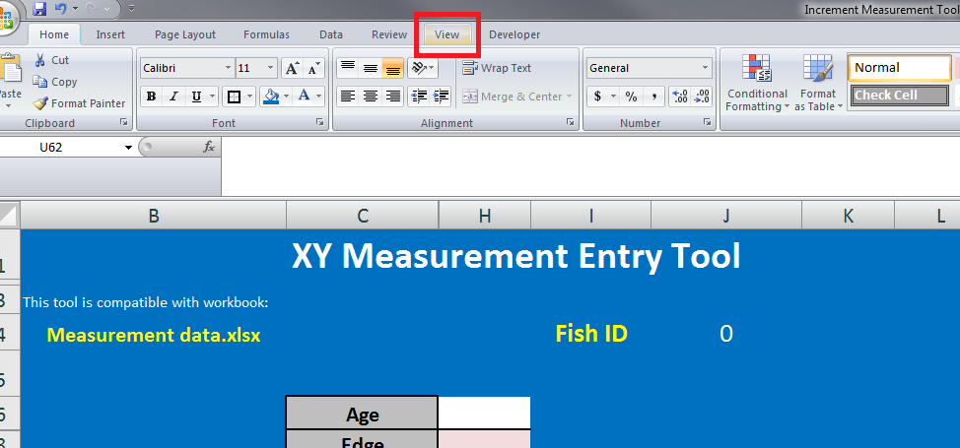Click View Tab
   2. Arrange All

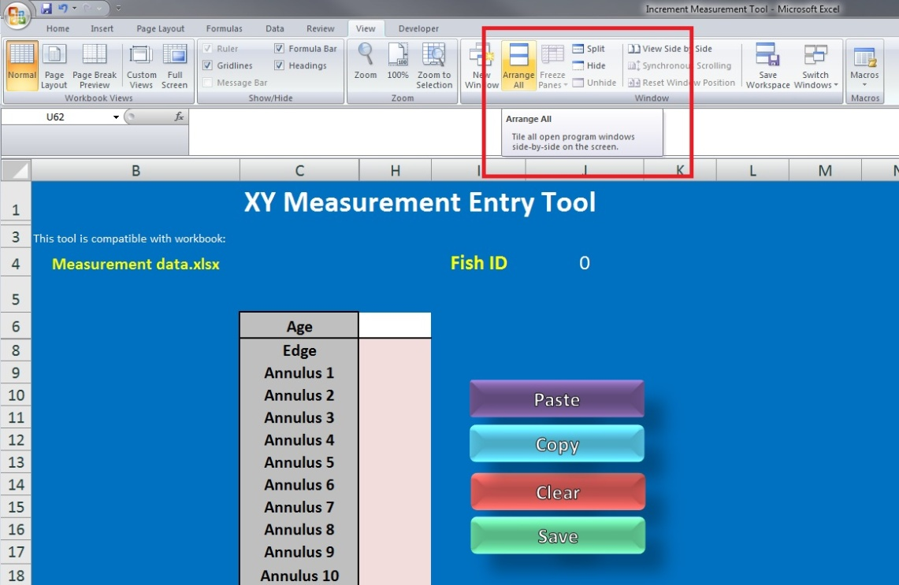

* 1. 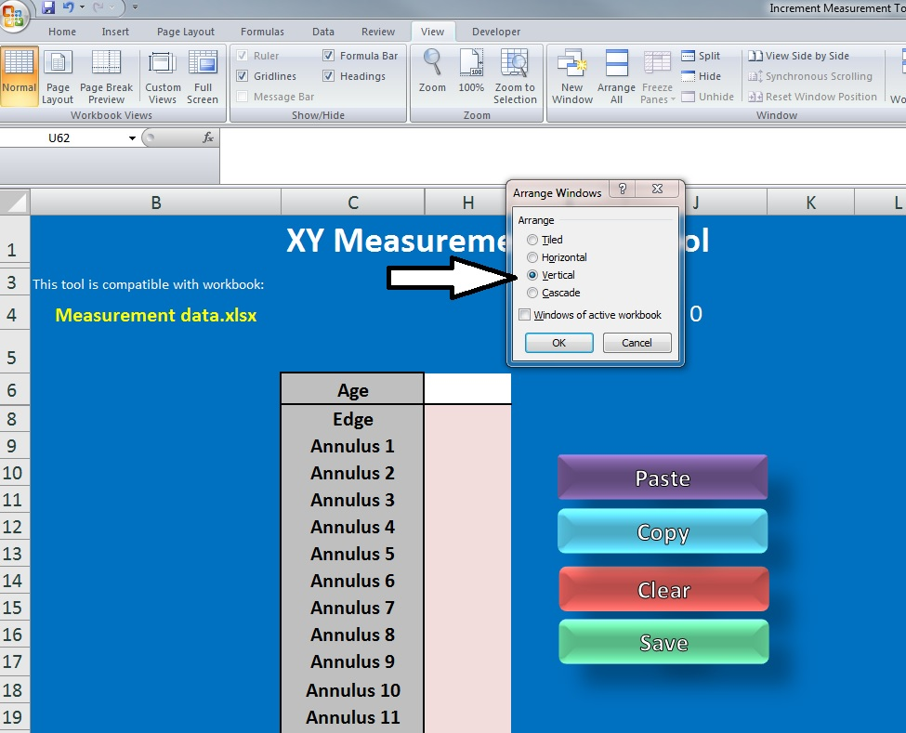Select Vertical
  2. 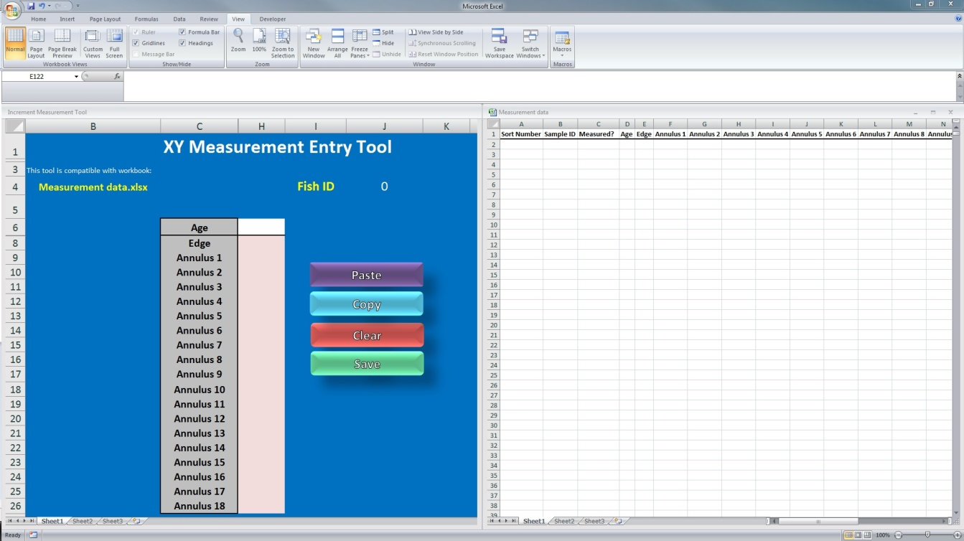The result should look like this

1. **Calibrate Image Pro/Insight**
   1. 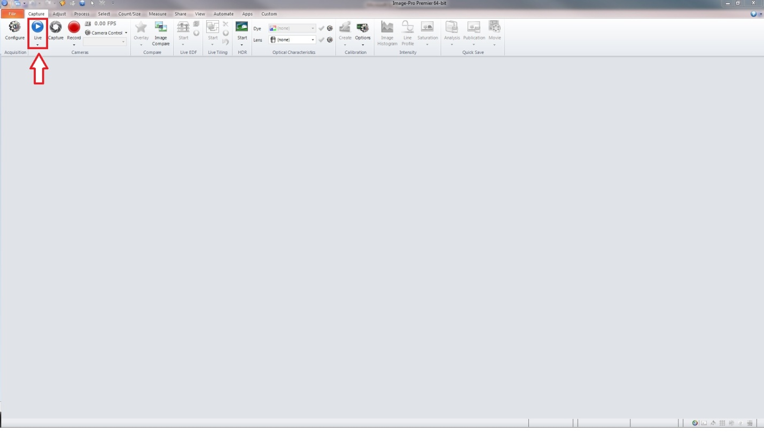Select Live Image
   2. 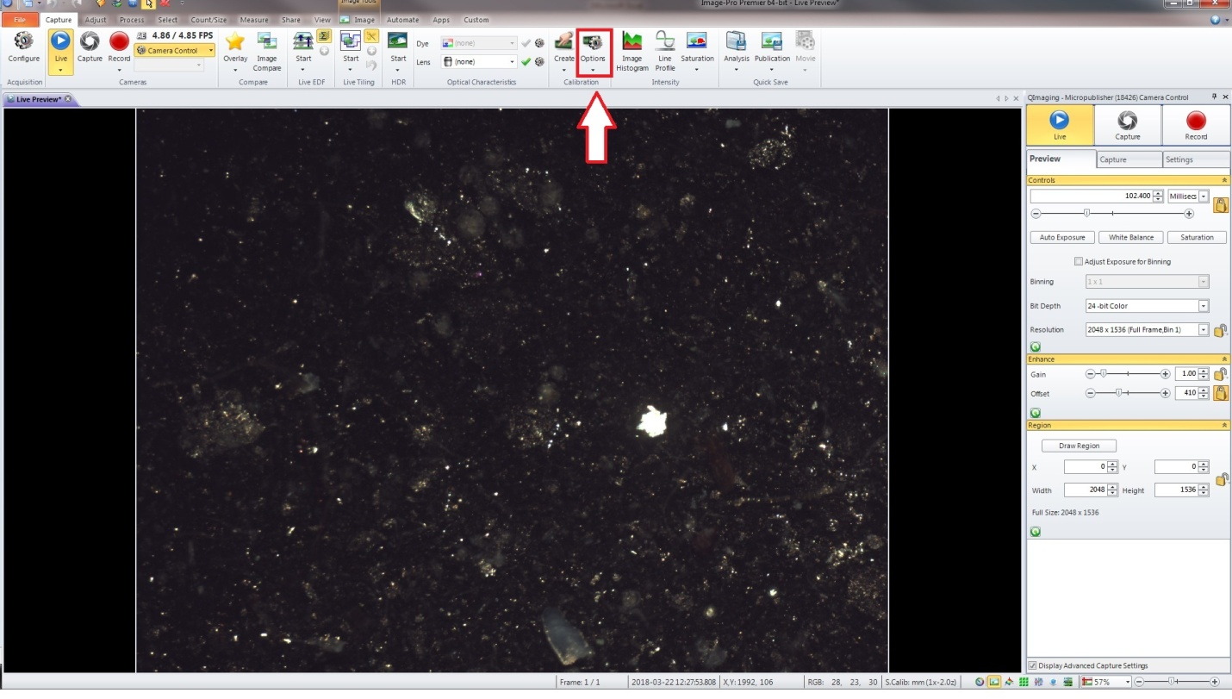Select Calibration Options (Click the button, or select Spatial Calibration options from drop menu)
   3. 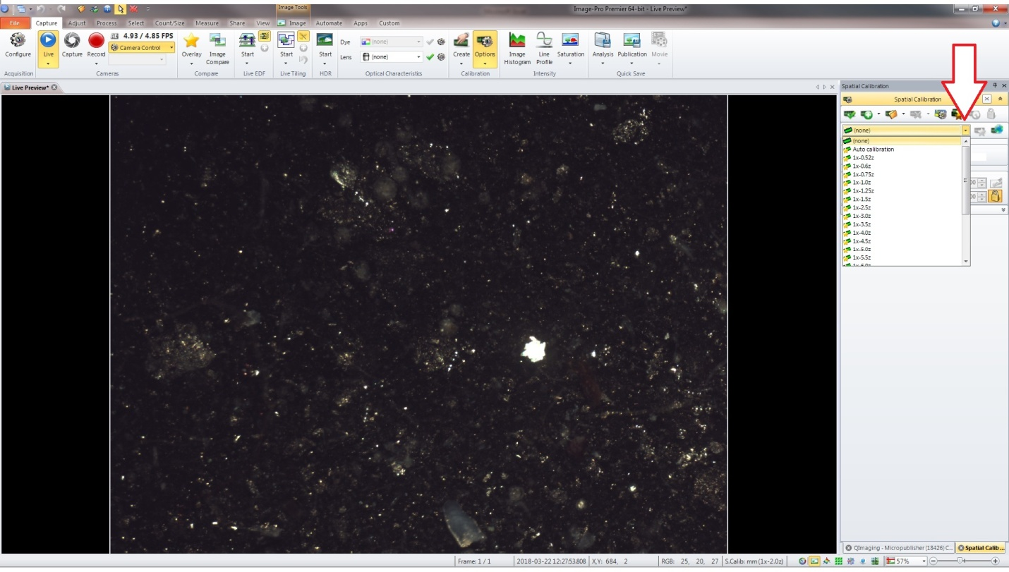Click the drop menu the arrow is pointing at in the next photo and select the calibration for the appropriate level of zoom you will be using to measure your structure. (For this example, since we are using river herring otoliths, we will be using the 2x zoom on the Optem ZOOM 125 microscope)
   4. 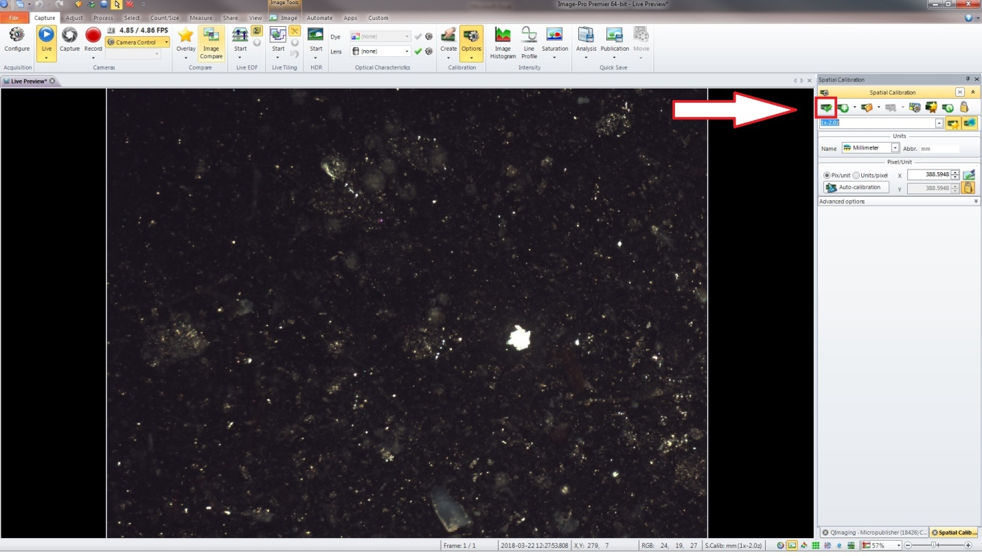Once you have selected the calibration setting matching your zoom level on the microscope, be sure to hit the check box to calibrate Image Pro/Insight.
   5. To make sure the system is set to the correct spatial calibration; the bottom tool bar will tell you what the current spatial calibration setting is.

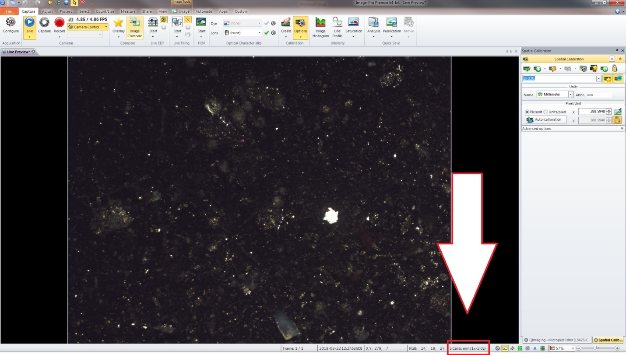

* 1. 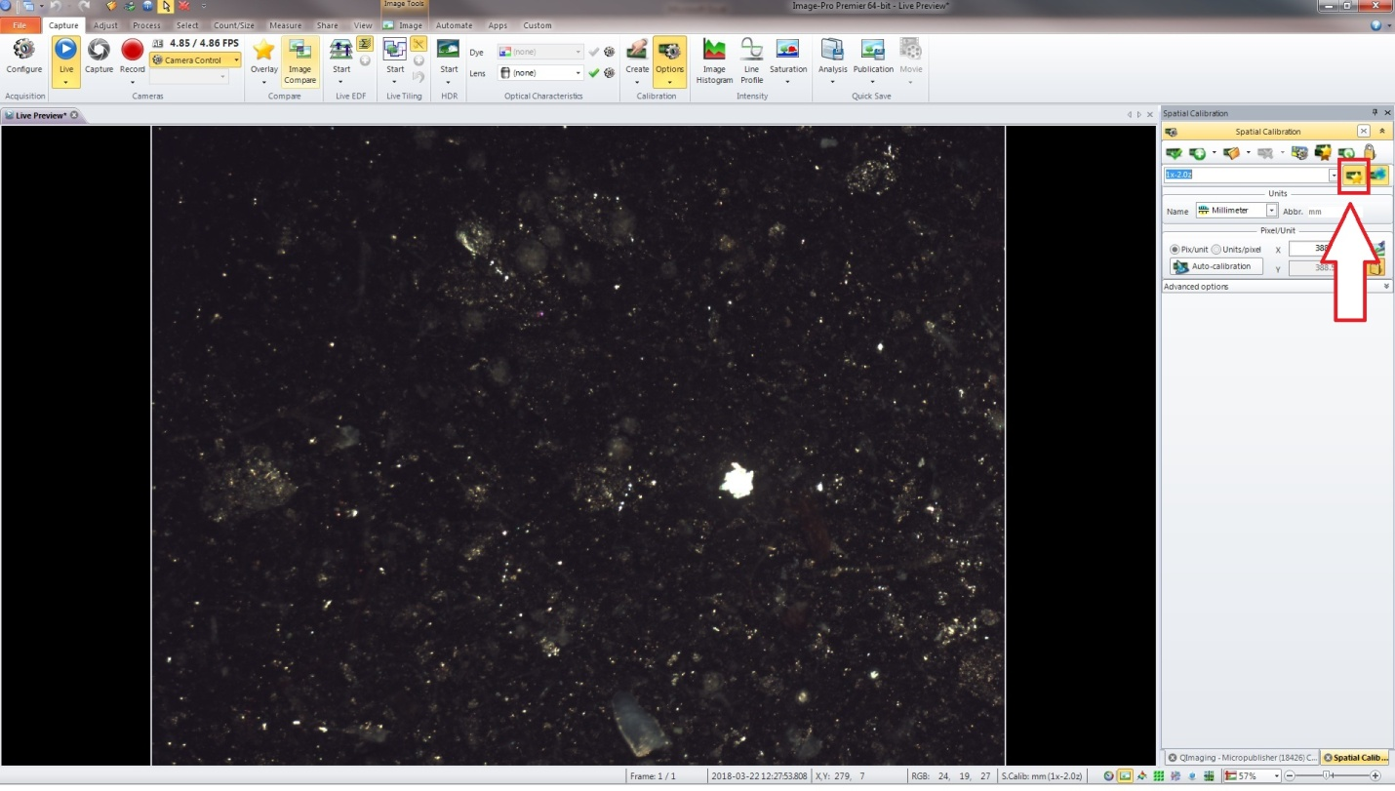If you want Image Pro/ Insight to remember the spatial calibration you set it at for future sessions, click the reference toggle (the single star w/ ruler next to the drop menu to select a calibration). Always be sure to check the current spatial calibration setting in the bottom toolbar (Step 3e)

1. **Measurement data.xlsx prep**
   1. Copy sample id numbers from your biological data sheet and paste them into column B in Measurement data.xlsx (in this example, our data source is “D:\River Herring\2017\RARH 2017”) \**\*Be sure to copy sample ids in the order in which you will be measuring them\*\**
   2. 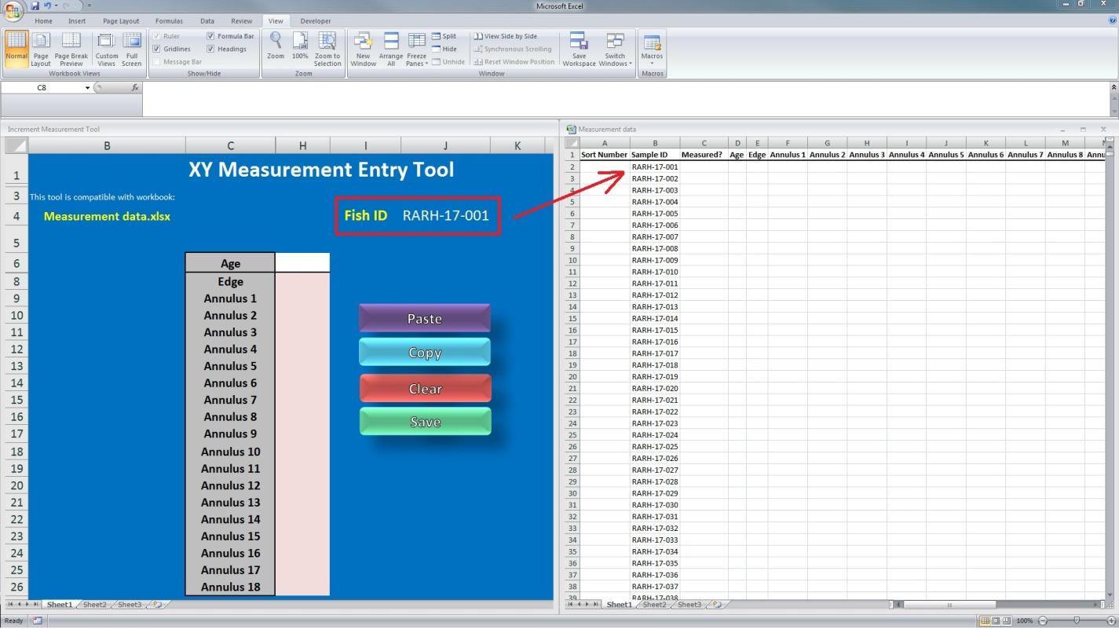Check the Fish ID on Increment Measurement Tool.xlsm, this should match the first sample you want to measure. (in this example, RARH-17-001)
2. **Measuring Structures**
   1. Place your structure you wish to measure under the scope and focus the image.
   2. 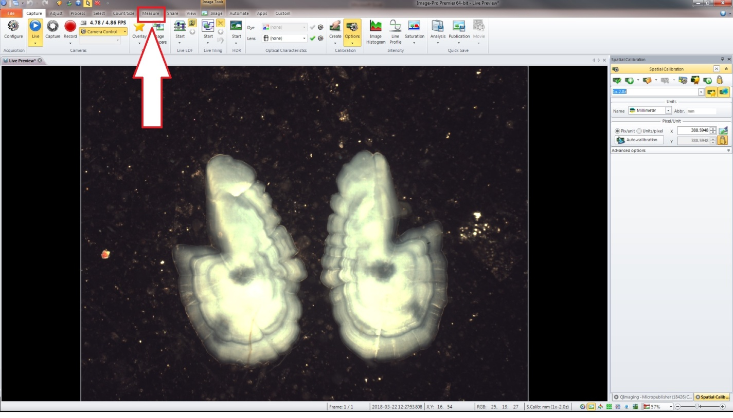Select the measure tab
   3. 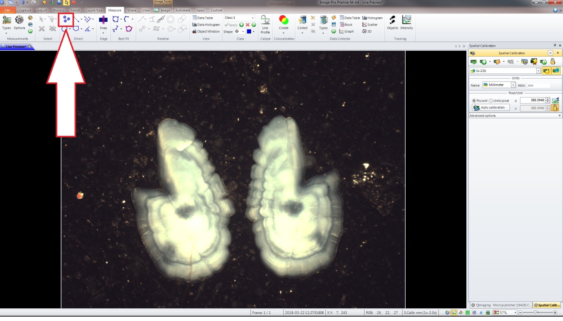Select the Manual Tag tool *\*\* Since The Increment Measurement Tool.xlsm calculates distance using Cartesian coordinates ( $d=\sqrt{(x_{2}-x_{1})^{2}+(y_{2}-y_{1})^{2}}$), the Increment Measurement Tool.xlsm will* ***NOT*** *work with any other Image Pro/Insight measurement tool (ie Point to Point measurement)\*\**
   4. 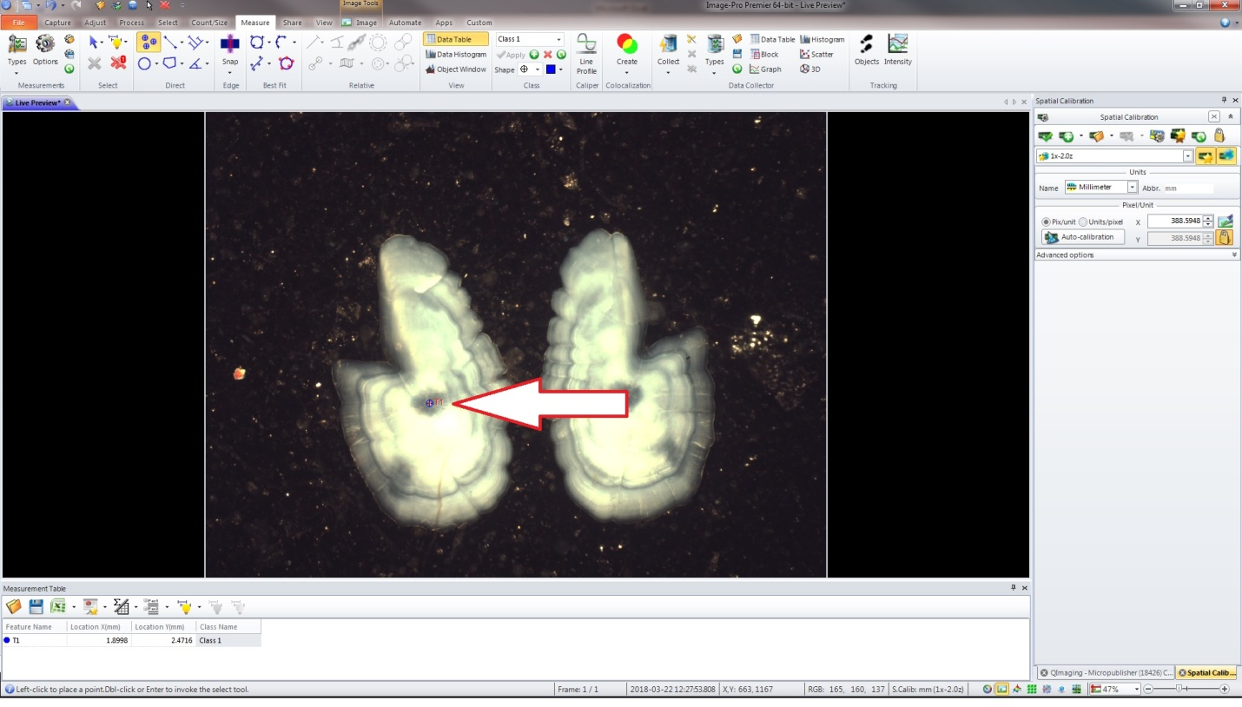Always start measurement by selecting measurement origin point (ie the core)
   5. 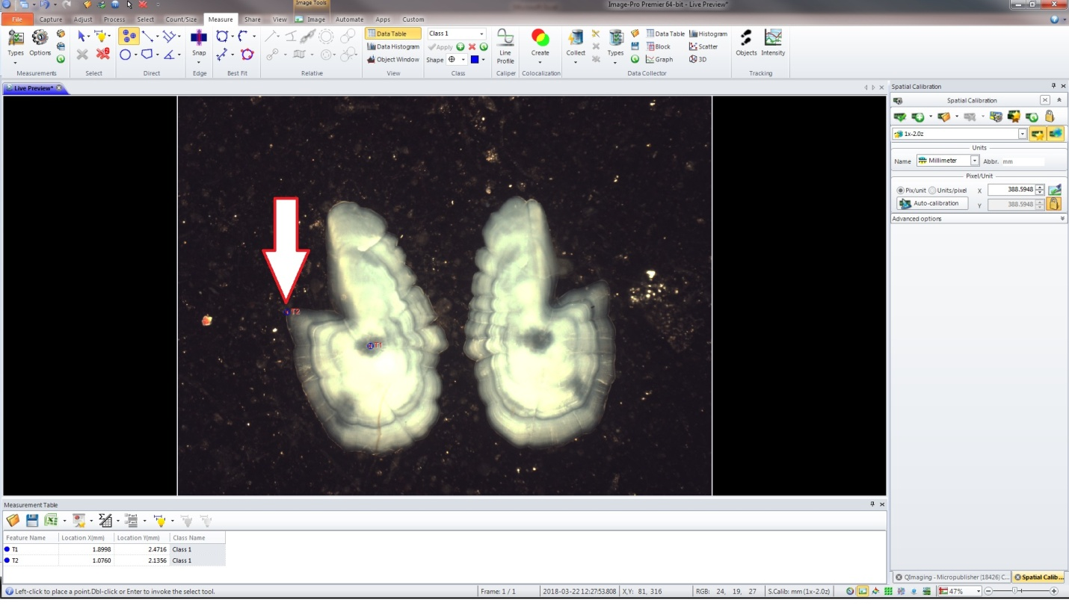Select the edge of the structure
   6. 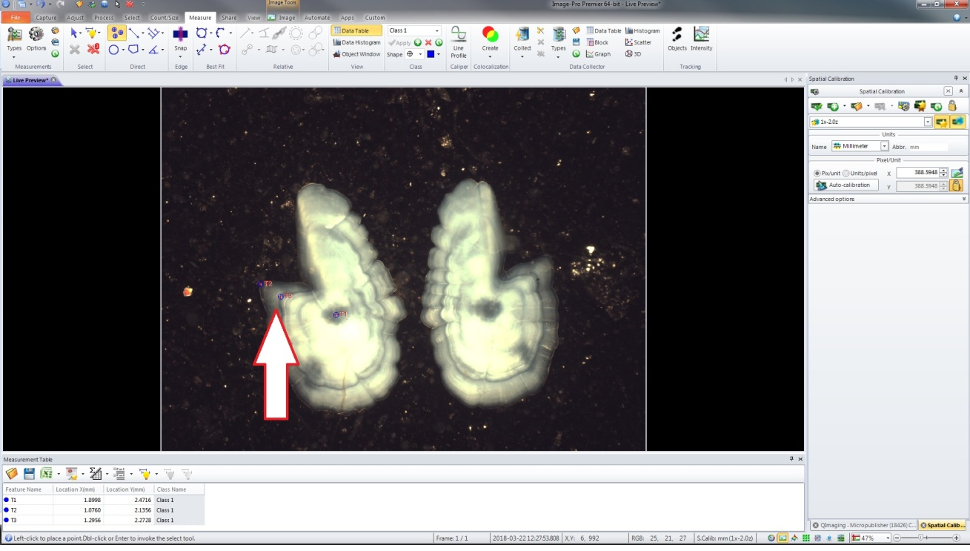Select the increments you wish to measure in sequential order (ie first annulus, second annulus, third annulus etc)

*************************************************************************************

*For the Increment Measurement Tool to work properly, you must make sure that your export settings are set correctly*

To set the export options, select the drop menu in the measurement table next to the Excel Icon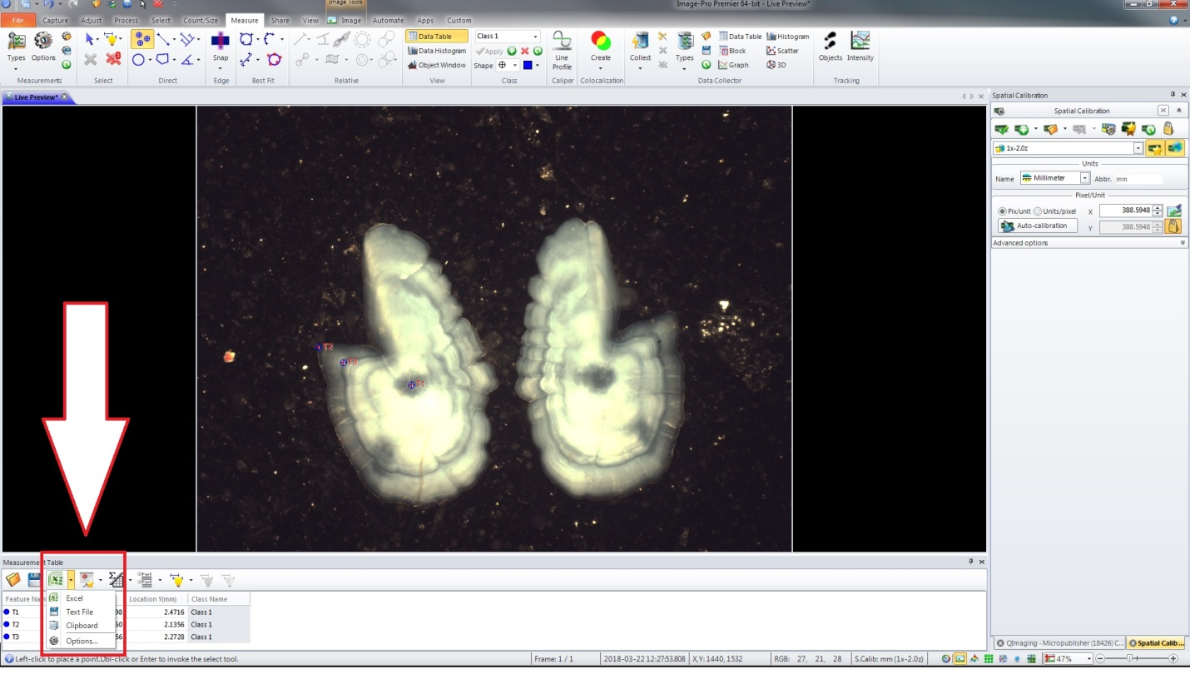

Select Options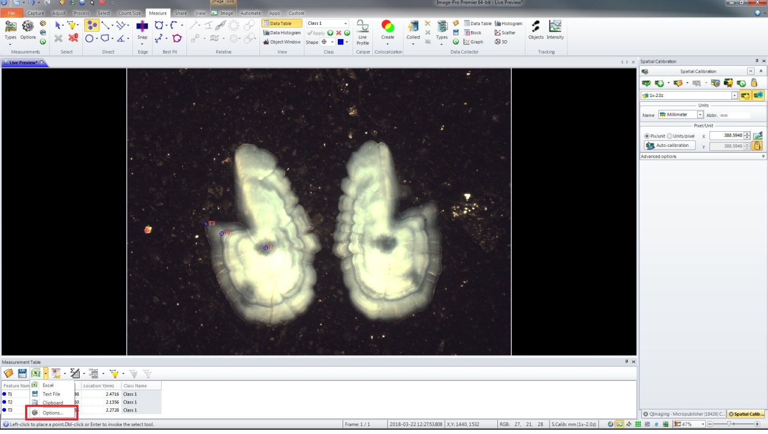

Make sure that all the check boxes (In the Export Tab) are **DESELECTED**

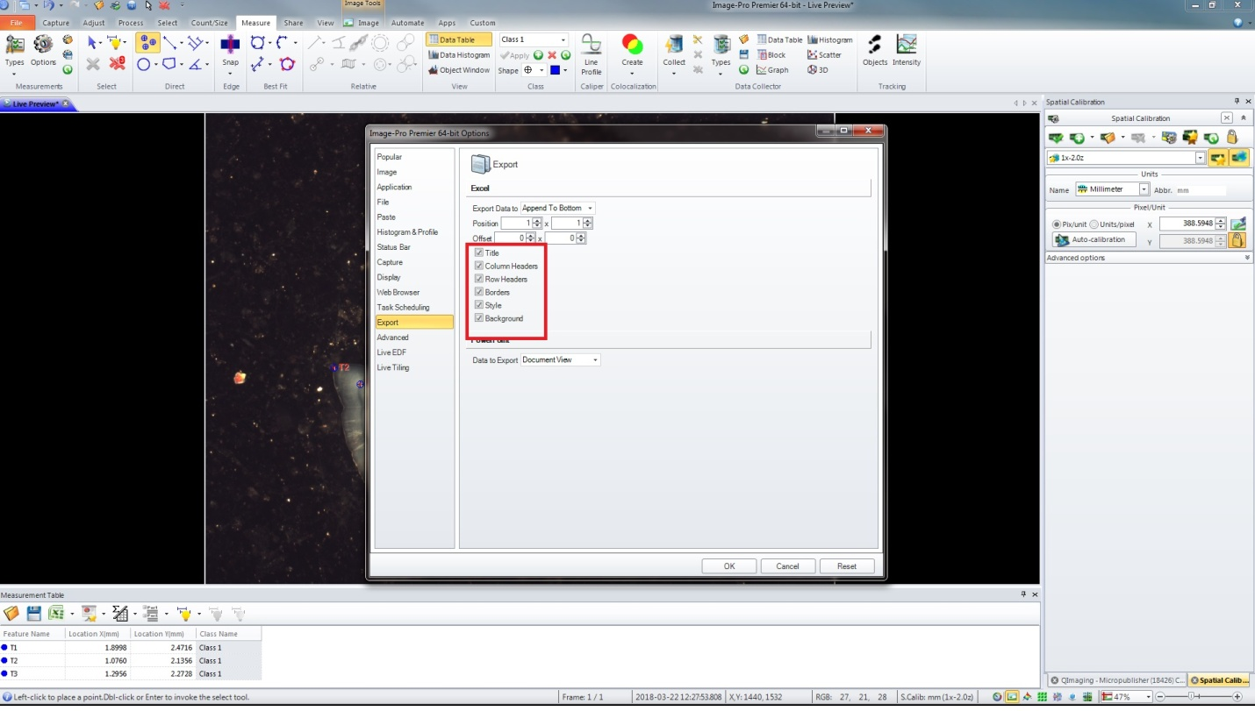

**\*\*\*\*\*\*\*\*\*\*\*\*\*\*\*\*\*\*\*\*\*\*\*\*\*\*\*\*\*\*\*\*\*\*\*\*\*\*\*\*\*\*\*\*\*\*\*\*\*\*\*\*\*\*\*\*\*\*\*\*\*\*\*\*\*\*\*\*\*\*\*\*\*\*\*\*\*\*\*\*\*\*\*\*\***

* 1. Once you have finished selecting the increments you wish to measure, select the drop menu in the measurement table next to the Excel Icon and select Clipboard (this will put your data onto the clipboard so you can copy it into the Increment Measurement Tool.xlsm)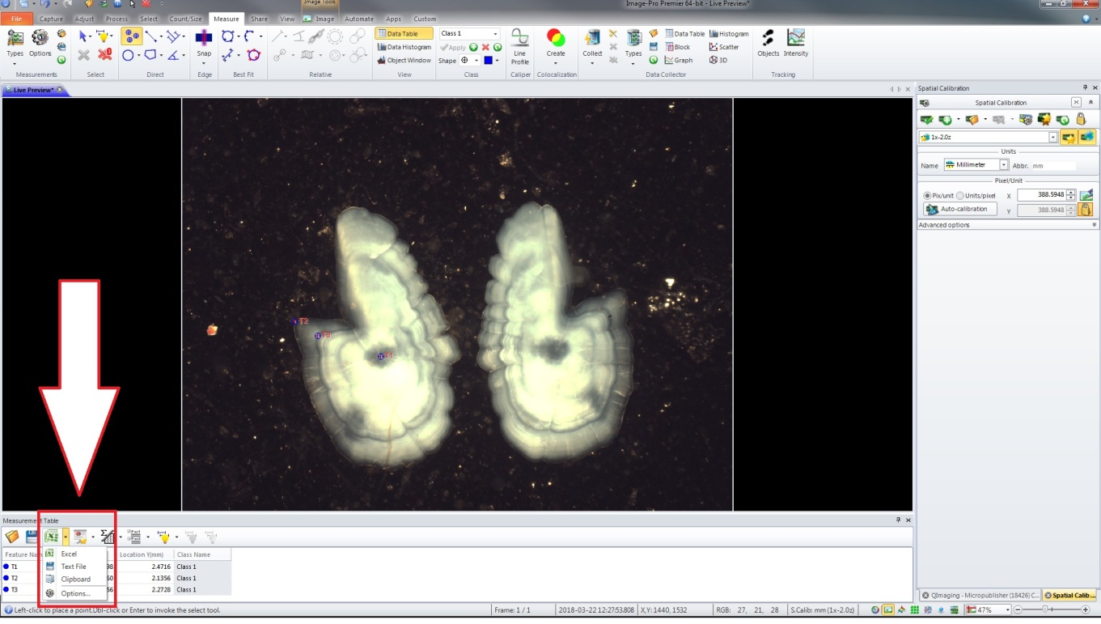

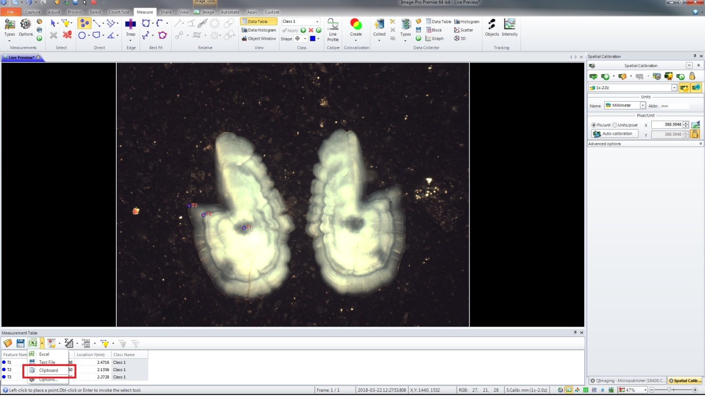

* 1. In the Increment Measurement Tool.xlsm, click on the Paste Button

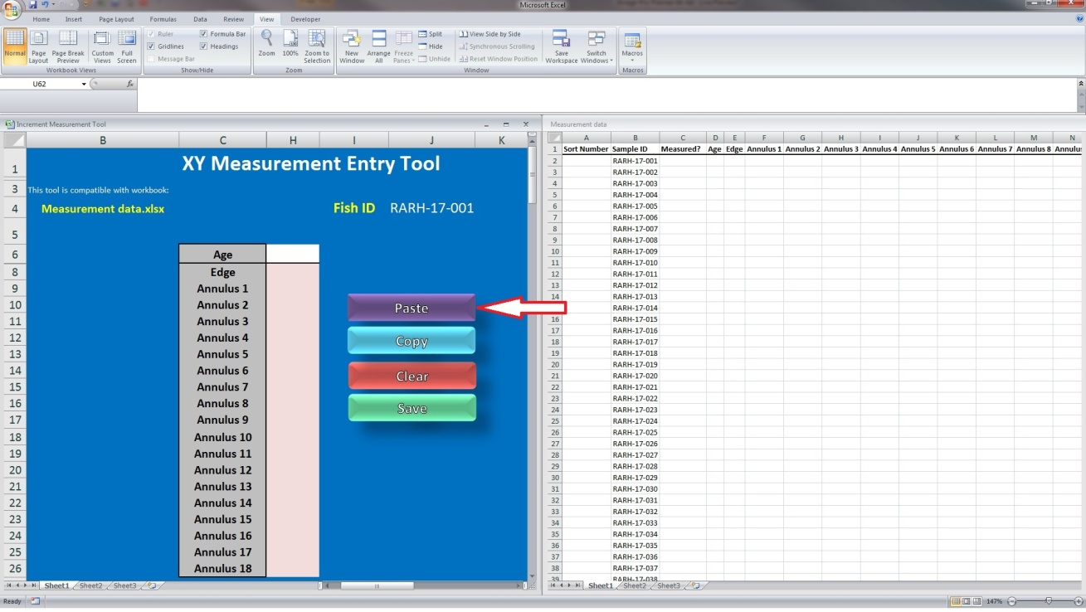

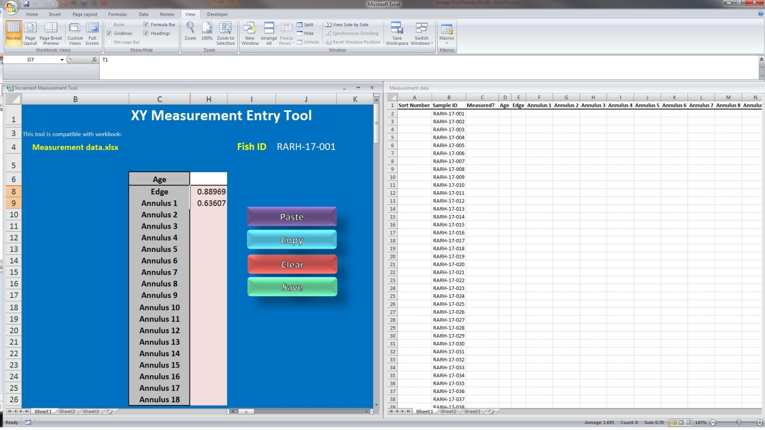

* 1. If you wish to enter ages while you are measuring age structures fill in Cell H6 with the desired age (Since this is a spring caught river herring, we count the edge, so our example fish is 2 years old)
     1. 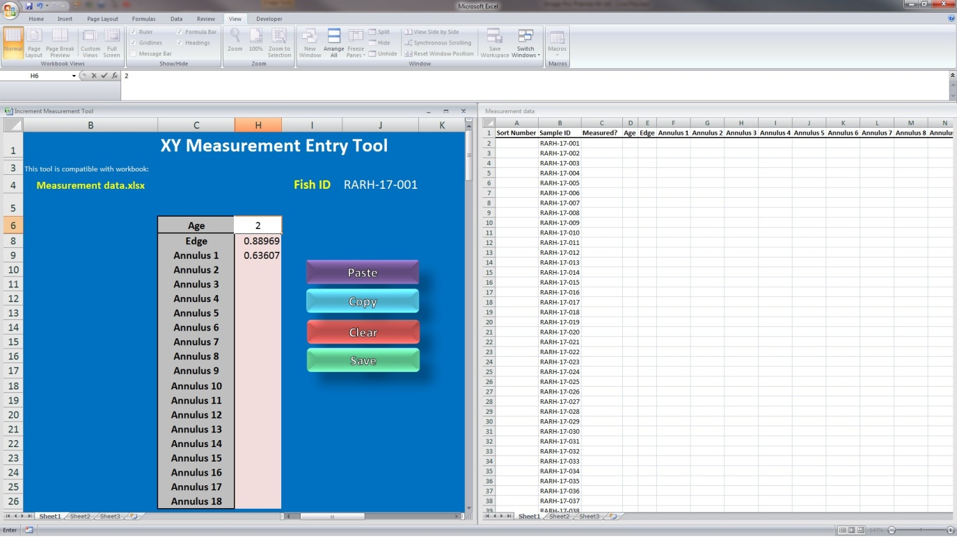If you **DO NOT** wish to age the fish (ie they have been previously aged) leave cell H6 Blank
  2. 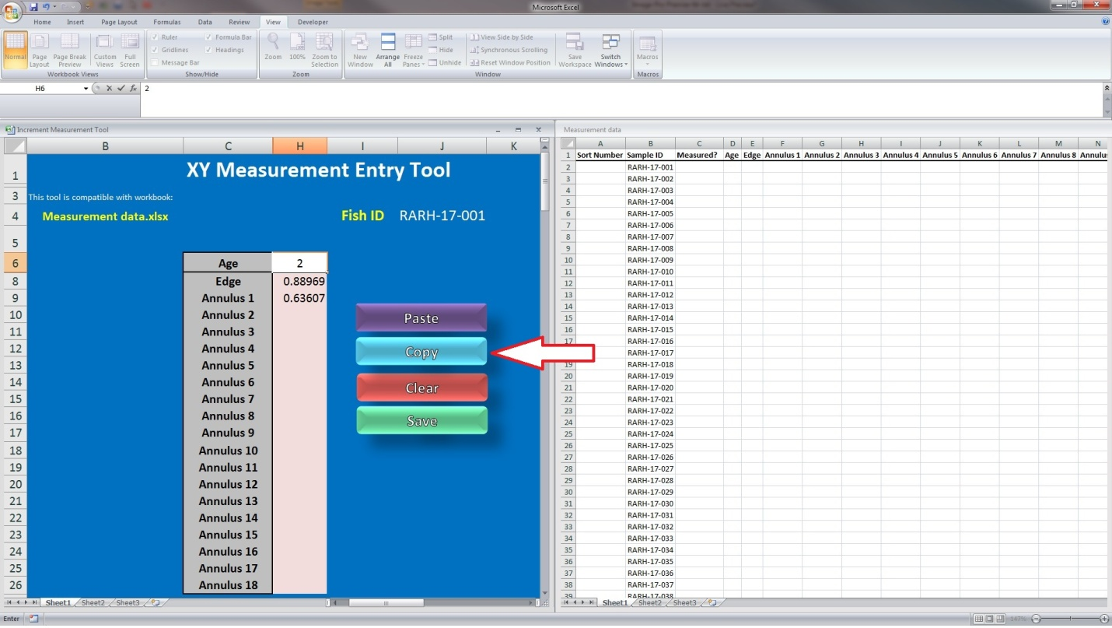Click on the Copy Button, and your data should appear in Measurement data.xlsx

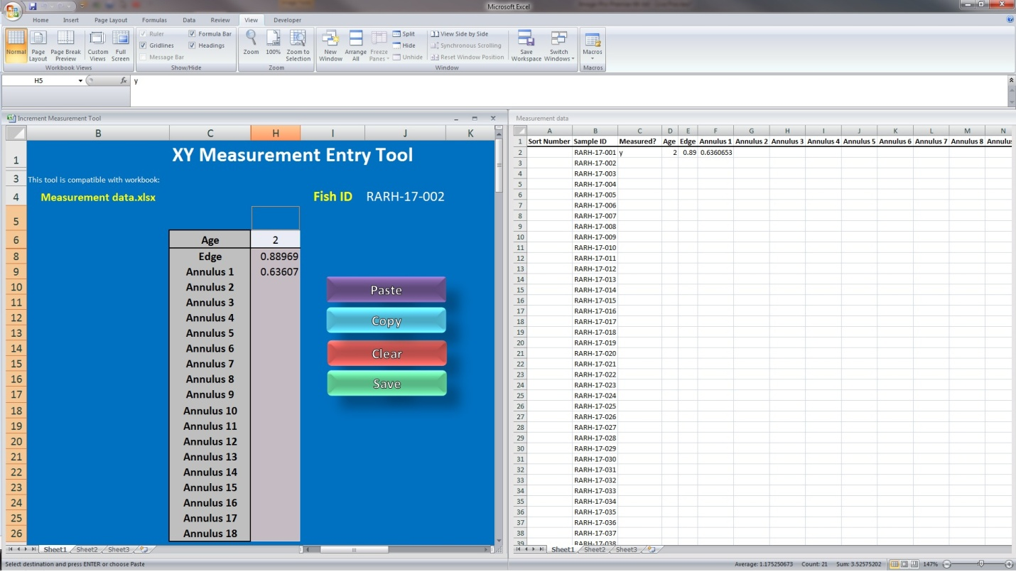

**Note: a y should show up in column c. The y comes from Cell H5 in the Increment Measurement Tool.xlsm (ICM). It is **very important** that the cell in column c is filled with a value (I have chosen y for simplicity). This is how the ICM knows where to paste the data into Measurement data.xlsx, as the ICM looks for the first blank in column C and pastes the data in that cell. ***

* 1. Once your data has been successfully pasted into Measurement data.xlsx, hit the clear button (This function clears that hidden data in cells D6:G26)

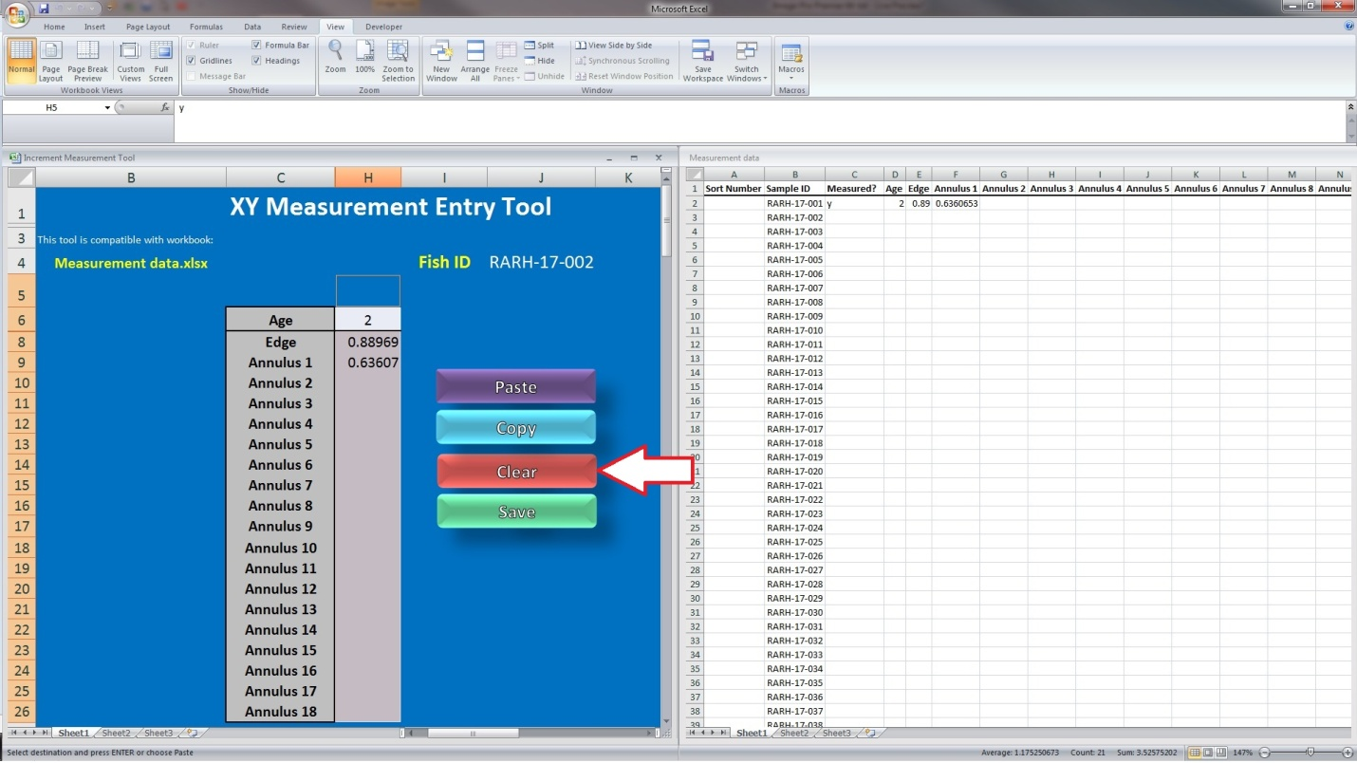

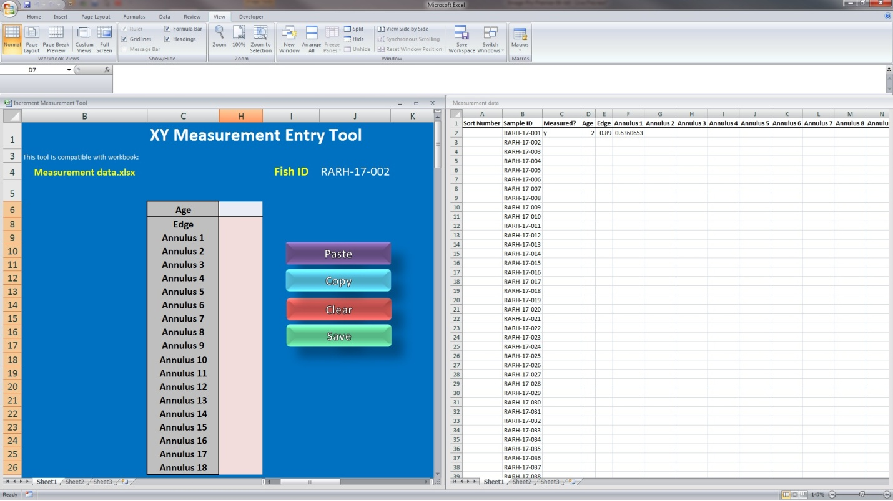

* 1. Hit the save button (This function overwrites Measurement data.xlsx)

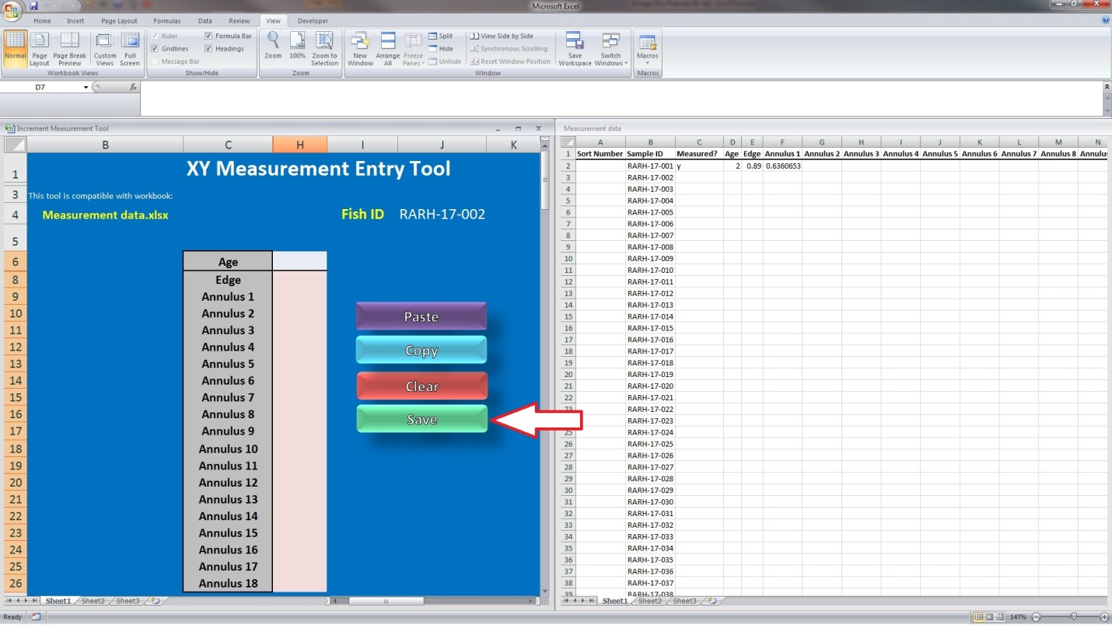

* 1. In Image Pro/ Insight, select the double x icon to clear the current measurement points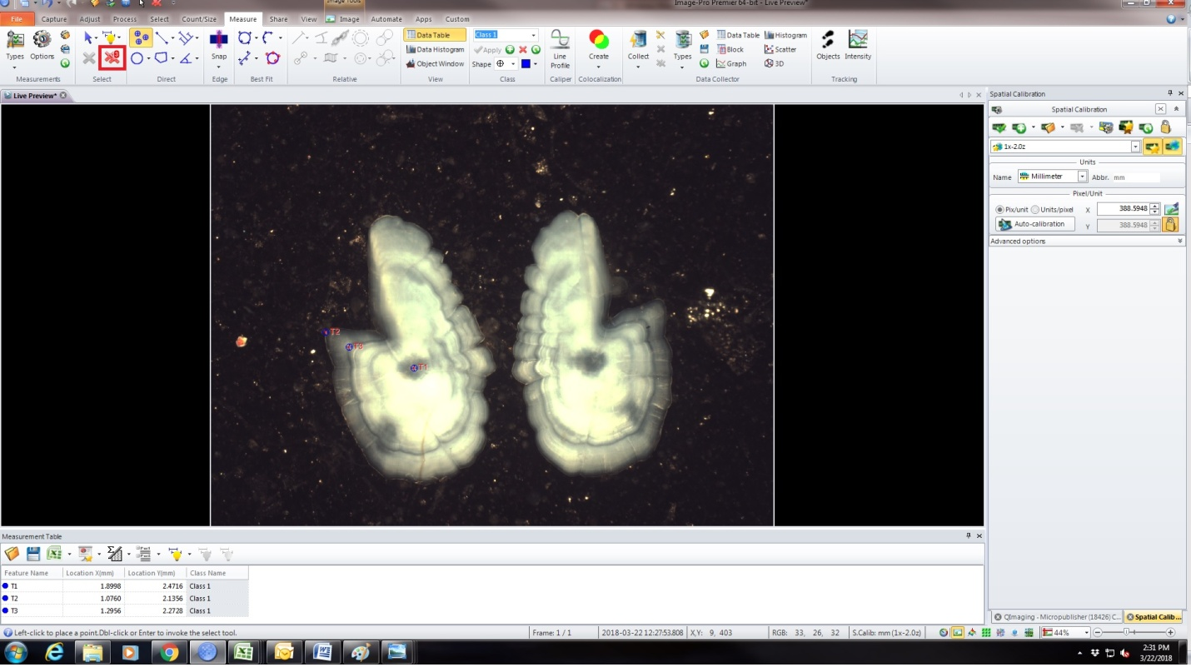
  2. Move on to your next age structure
  3. Repeat steps 5d-5n until you finish measuring all of you desired age structures

**REMEMBER: DO NOT change the file name for Measurement data.xlsx! When you are finished with all measurements, SAVE AS the file in a different location and clear the contents in Measurement data.xlsx for next use**